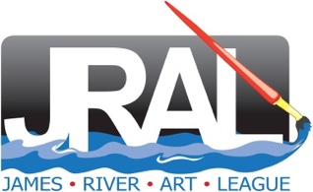 | Jane Bodnar
I am a professional artist formerly from New Jersey who is currently based in Richmond, Virginia. My paintings are primarily done in pastels and include landscapes and portraits of people and animals. I hold “Exhibiting Membership” status in the James River Art League and the Mid-Atlantic Pastel Society.

As an artist, I express my love for painting and in the subject I choose to paint. I use light and color to create an emotional atmosphere in my work. For example, light and shadow are important in my landscapes just as playful colors are used with my animal paintings and sensitive line are important in my portraits.

I believe that emotion is the key element in creating paintings that pull the viewer into them. Pastels facilitate this emotional environment because of their immediate and rich colors.

