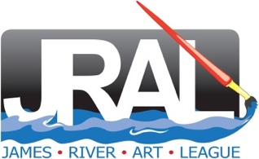 | Carol Baron
I have been interested in art all my life, starting as a child with handmade valentines, moving on to dabbling with mediums throughout high school and college. I spent a dozen years throwing pots, working with a group of fellow artists in my home studio and then starting an art league in the Chicago area. All of this fun was interrupted by a different kind of pleasure--the arrival of four kids who needed to be raised and sent to college.

My mother was my inspiration for turning back to art. She took up art again after a long child-rearing break and clearly loved it. I wanted the same great experience.

My paintings are based on my experiences which I try to capture in photos that I later use as ideas for my paintings. All the paintings in this exhibit were inspired by scenes I found captivating -- Pelican 2 from hours watching a pelican dominating a river post; Reploy Yourselves! from hours of watching these flamingoes vie for space; BEEutiful from a walk in the Lewis Ginter gardens; Brooklyn Roots from literally stumbling on this iconic Brooklyn street; and Poppy Fun from enjoying a garden burst of poppies.

I have learned from studio time with Adele Costillo, Christaphora Robeers, Robin Caspari, Anne Chaddock, and other local artists. I thank all of my instructors and fellow artists for showing me this wonderful life of painting. I also thank my family for recognizing that they cannot have all of my time and attention!

